WhatsApp
https://whatsapp.com/dl/
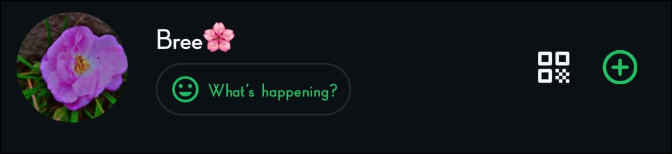

Instagram https://www.instagram.com/invites/contact/?utm_source=ig_contact_invite&utm_medium=copy_link&utm_content=ncbryc9
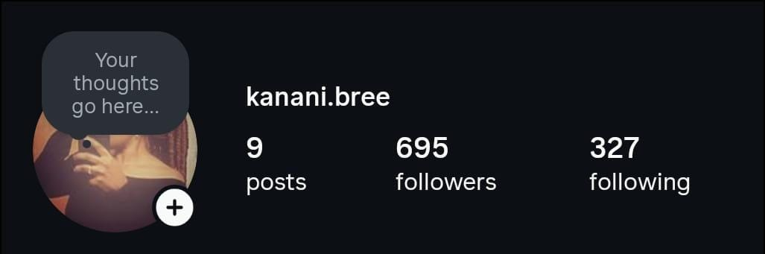

Twitter (X)
https://x.com/kananibree
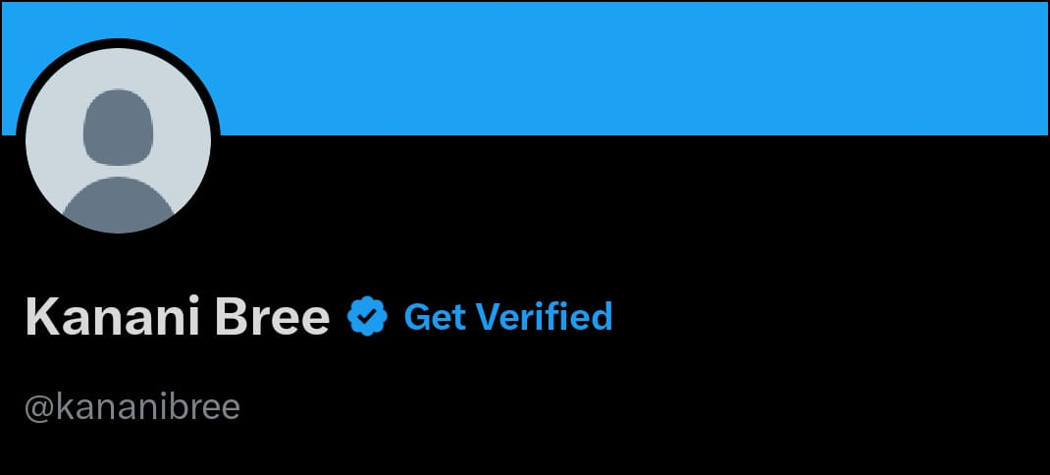

LinkedIn
https://www.linkedin.com/in/brenda-kanani-a68850298?utm_source=share&utm_campaign=share_via&utm_content=profile&utm_medium=android_app
